Bug Report Template

Bug ID:
Notes - #1
Title:
Notes Title and Content missing text wrap
Environment:
Browser: Chrome – (All Browser)
OS: Windows
Device: Desktop Viewport
Build/Version: 1.0
Preconditions:
- Log in to VerseByVerse
Steps to Reproduce:
- Navigate to /study
- Have a title that is one word long enough to exceed the input box containing the title
- Have a note content that is one word long enough to exceed the input box containing the title
- Open the Notes tab
Expected Result:
Title and content of the notes should safely wrap the long word and omit & or hide the text from going out of the box
Actual Result:
Title and content texts are going out of the box and creating a sidebar horizontally.
Severity:
Low
Priority:
Low
Status:
In Progress
Attachments:
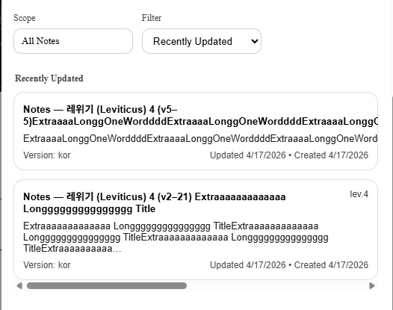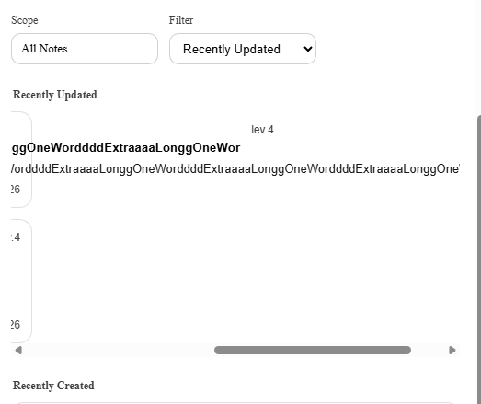
Notes / Root Cause (Optional):
Texts are not wrapped & omitting algorithm is not applied.

